Assignment 4

Marks for Assignment 4 total 100 (10 marks for each question).
1. What are the most important kinds of intermolecular forces present in each of the following substances?
a. toluene, C7H8
b. mercury, Hg
c. ammonia, NH3
d. ethanol, CH₃CH₂OH
e. chloroform, CHCl₃

2. For each pair of molecules, predict which would have the highest boiling point:
- CH₄ versus CH₃Cl
- HF versus HCl
- CH₃CH₃OH versus CH₃CH₂F
- CH₄ versus CI₄
- PH₃ versus NH₃
- Answer the following questions:
- Which of the following compounds would show hydrogen bonding in their pure liquid state?
i. CH₃OCH₃
ii. (CH₃)₂C=O
iii. CH₃CH₂OH
iv. CH₃NH₂
v. (CH₃)₂NH
vi. (CH₃)₃N
vii. CH₃F
- Draw structures to show all the types of hydrogen bonding present in an aqueous solution of acetic acid:
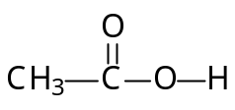
- For each pair of compounds below, draw a dashed-wedge line structure of the more polar compound and show the direction of its dipole moment. You may ignore any polarity of the C—H bonds.
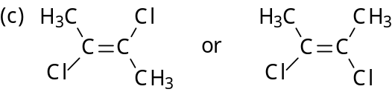
- Answer the following questions:
a. For each of the following dash formulas, give the corresponding bond-line formula and molecular formula.
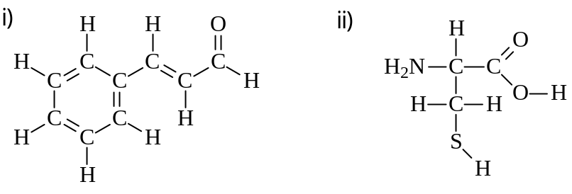
Cinnamaldehyde Cysteine
b. List all the functional groups in cysteine, (ii) above.

- Answer the following questions:
- In the following reaction, identify the Lewis acid and the Lewis base.
- Ethanol can act as a weak acid or a weak base. Write the equation showing the reaction of ethanol, CH₃CH₂OH, with
- The methyl amide ion, CH₃NH–, a very strong base
ii. Concentrated phosphoric acid, H₃PO₄
- In the reactions in b) above, what are the conjugate acid of CH₃NH– and the conjugate base of H₃PO₄?
- For each of the following structures:
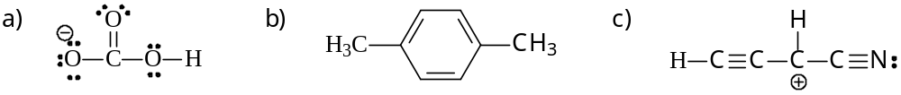
i. Draw the Lewis structure of any other possible resonance contributors.
ii. Indicate on your resonance contributor structures the atoms having any formal charges (other than zero).

- For each of the following species:
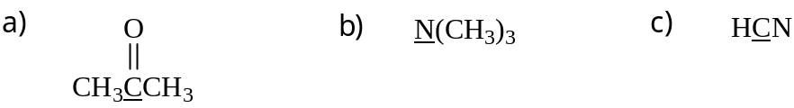
i. Draw the Lewis structure.
ii. Predict the shape around the underlined atom.
iii. Give the hybridization of the underlined atom.

- Answer the following questions:
- Classify the following as 1°, 2°, or 3° alcohols.
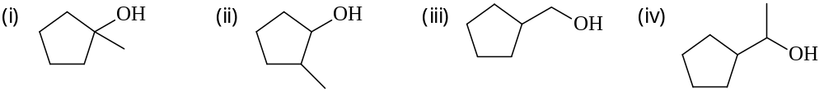
- Classify the following as 1°, 2°, or 3° amines.
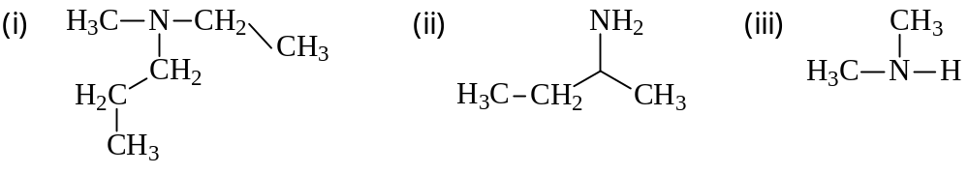
- Draw two different structures (in bond-line notation) for each of the following:
- A secondary alkyl bromide with the formula C₅H₁₁Br
- A cycloalkane with the formula C₇H₁₄
- An aromatic aldehyde with eight carbons
- A four-carbon amide
- A cyclic ketone with the formula C₆H₁₀O

